Family Notings 2000-2015
Year End diaries-2008 to 2015

Lodhi Gardens- Delhi-2000 Leptis Magna-Libya-2004

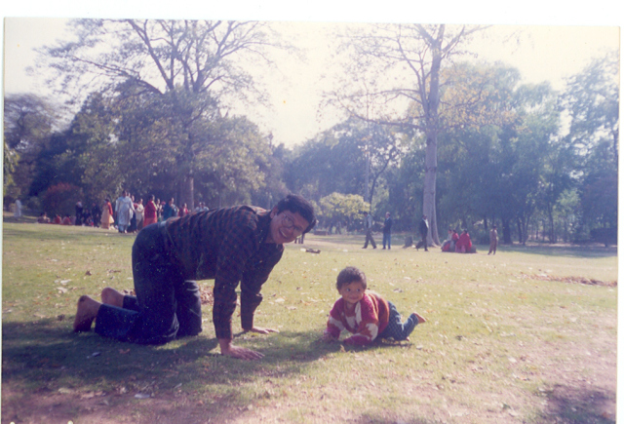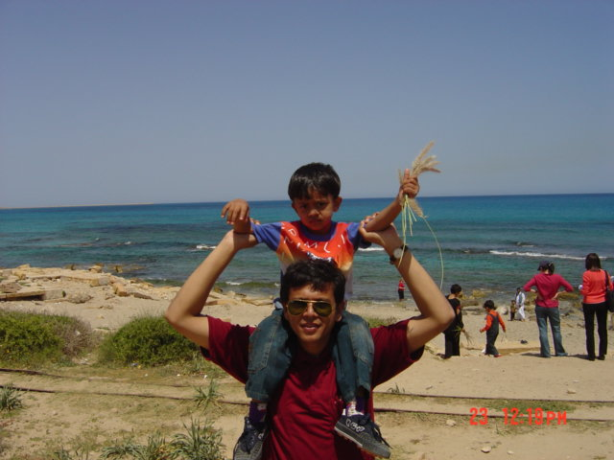

St.Edwards-Cottonera-Malta-2011 Port Credit-Mississauga-2015

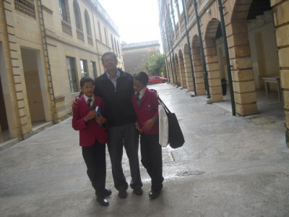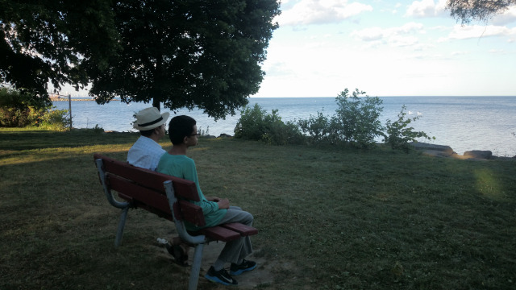

2008

With the person who taught me to make notes

http://wp.me/piL5Q-3y

The man who taught me to make small notes, a habit which has enriched my life more than any other single habit.

Here, we are together at Palam Vihar, with a Landscape painting presented to us by Mrs. Ramachandran, the wife of Brigadier Ramachandran, a senior anesthetist and colleague of my father.

Again, the changing dynamics of life, with death, jobs, and life, carry us to distant lands.
We talk on the phone but have not met in person for some years.

But the habit of making notes remains.

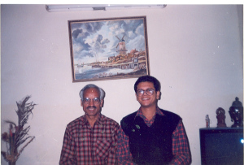

Palam Vihar- 2002

A race lost –a lesson learnt-2008

http://wp.me/piL5Q-3k

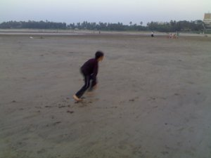

Sahil-Aksa beach-Mumbai-2008
The 200-meter race was on. The child who was leading the rest of the field by more than two lengths thought the race was over when he reached the finish line. However, the rules said that he had to cross the line. As he stopped, three others who were clearly behind him went ahead and crossed the line to “win.”
Training, he had been training for this race for some time now. A third-grade student was even taken by his father for a 2-kilometer run to Aksa beach to build his stamina. The 8-year-old boy easily defeated his 40-year-old father in the 2-kilometer beach run.
"You are getting old," a friend told his father as he proudly told of how he had lost to his 8-year-old son.
Lessons: Do not give up! One has to keep competing and trying till the last ball and last minute. Life is not always fair! This is a small race. In life, you will face many situations in which systems, positions, and contacts will decide things based on merit and hard work rather than on merit and hard work.
This is the way the world is made. So one has to be prepared for disappointments and keep working quietly, keep trying.
Life is a process, just one thing after another. When you lose it, start again.
Innocence- 2008

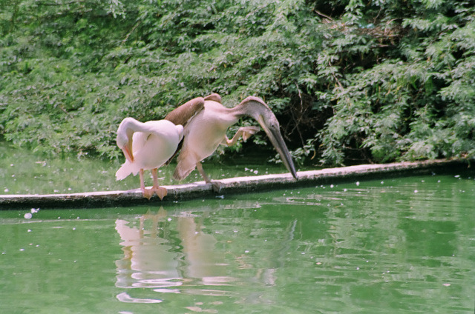

Pelicans-Delhi Zoo-2008

In November, I lost my passport on a visit to India. There were some troubled hours before I found it again, thanks to the railway police at Hazrat Nizamuddin, Delhi.

In all these troubled moments, many people helped me in their own ways. They congratulated me on having found my passport.

But my six-year-old nephew, Mayank, was the only one who was not happy about my finding the passport.
"Uncle, it is terrible that your passport was found."
"Why?" Everyone stopped to hear his reasoning.
“Because now you can go back to Tripoli and will not be taking me to the zoo.”
Such is life, as seen through the eyes of an innocent 6-year-old
2009
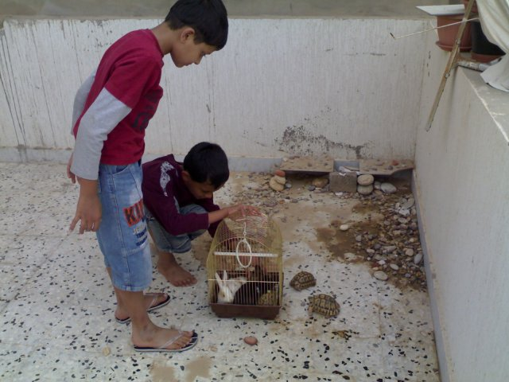

Sagar –Sahil playing with tortoises, rabbits in Shara Jraba-Tripoli-May 2009
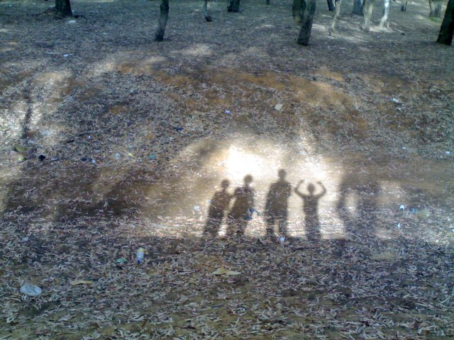
Walk in Khadra Forest. Morning Laughter club
2010
Walks in Malta again
http://wp.me/piL5Q-b5
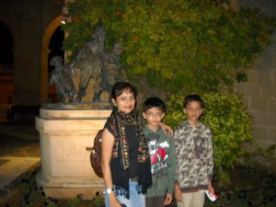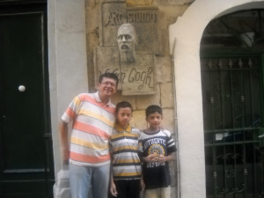
Upper Barakka Gardens, Malta, September 2010 Theater Manoel
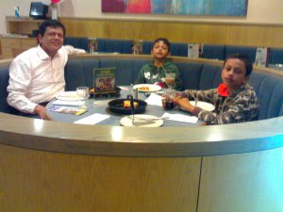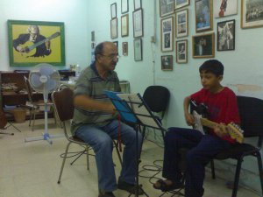
Pizzahut-Valletta-Near Museum of Fine Arts Tony Pace-Guitar teacher-Musician-St.Venera

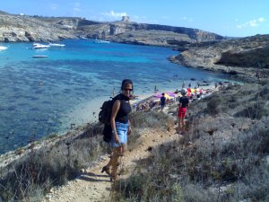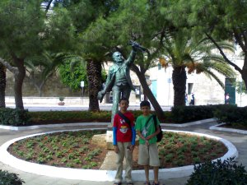
Comino Manwel Dimech
Dec 2011

What is Satsang http://wp.me/piL5Q-go

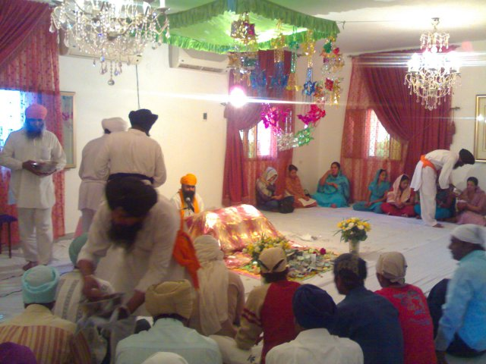

Indian community-Diaspora links- Nanak Jayanti-2010-SSB Camp-Suani

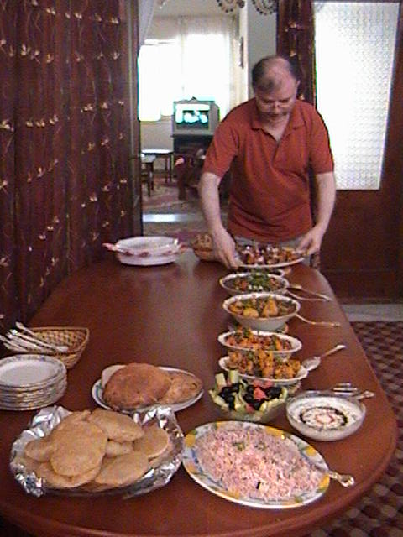
2009-5 Mr.Deshbandhu Snehi-Head of Chancellory-Minister-Indian Embassy-Tripoli

Friends of Bouazizi – Year-End diary-2011
Meeting –Tripoli Reading Group- 2011- http://wp.me/piL5Q-iP

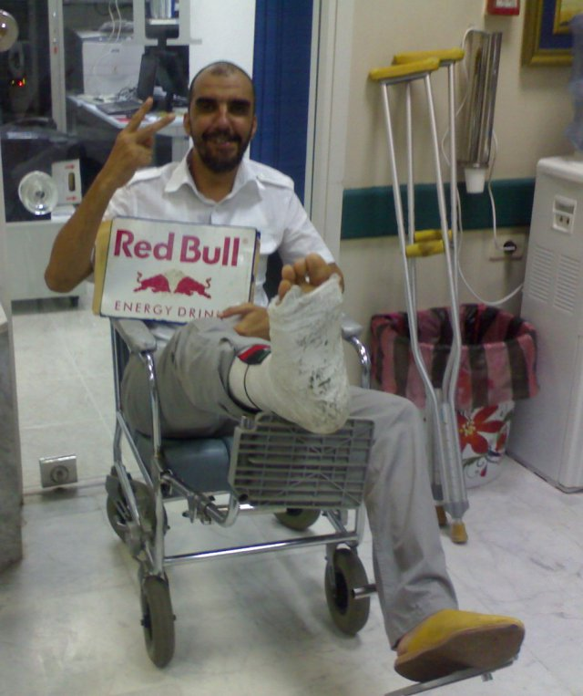

Yasin
2012-Rastafari http://wp.me/piL5Q-sX

-The curator, Veerle Poupeye, did well to bring out some interesting visual art pieces and introduced the concept of Rastafari
"While the nationalist school had already consecrated aspects of the popular culture as the definite core of Jamaican culture, they had treated this popular culture as a subject rather than as a source of 'legitimate' art in its own right. This, too, changed in the 1960s, when popular cultural expressions became more publicly assertive and gained national visibility and recognition.

Skype parenting http://wp.me/piL5Q-t7

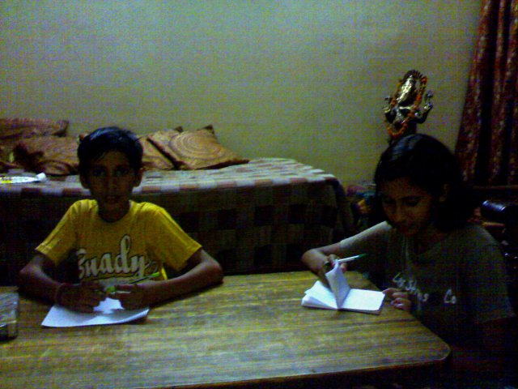

Divya and Mayank- Jasola -Delhi Making notes together-Writing Joint diaries,
Reflecting on visits to Jim Corbett National Park
park, the visit to Mussoorie, reading Ruskin Bond's
“Panther’s moon” and remembering the Aarti
at Ramjhula Rishikesh, where the
environmentalist Sunderlal Bahuguna was also
present on the day the children attended

2013- Year End diary
http://wp.me/piL5Q-AU
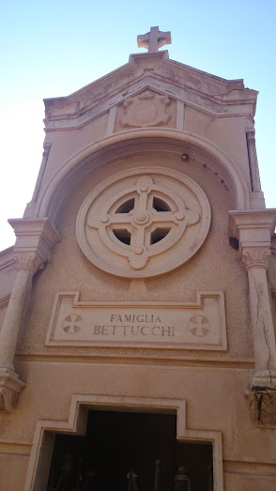
As we look back at the year, I recall the letter of my friend Alvaro Bettuchi and remember a fellow practitioner of faith and family of the 19th and early half of the 20th century.http://bettucchi.com/unforgettables.en.html
Born on June 29, 1857, at Castel di Casio, whose father was Giovanni Michele Bettucchi and mother, Catrina Taglioli. On June 2, 1878, there was an anti-lightning wire hanging from the side of the “Asinelli” towers, which are located in the center of the city of Bologna. In less than 15 minutes, he climbed to the top and descended the 100 meters outside the wall of the tower. He was arrested by the local authorities, but later released. He wed Luigia Delle Fabriche, who was born in 1866 and died in Tripoli on Jan. 19, 1931. In Tripoli, Libya, where Pietro emigrated, he formed a construction company, together with his son Pietro and daughter Margherita. He died in Tripoli on Dec. 25, 1933. He and his wife are buried in a private chapel within the Christian Cemetery at Gargarish, Tripoli. Interacting with his descendants gave me a better feel of Tripoli through the centuries and added to Margaret Atwood's words.
“There is always more to be known about it than you can ever know.”
Year-End diary-2014

Remembering walks and readings

http://wp.me/piL5Q-IL

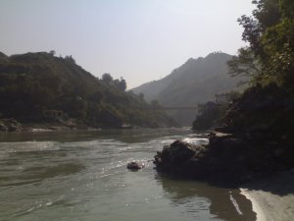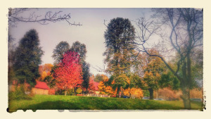

April 2014 Walks by Ganga, September 2014 Walks Central Don
Rishikesh-India Toronto-Canada

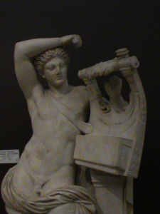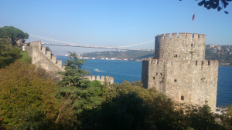
Museum Walks- Rumeli Fort
Istanbul –Turkey Bosphorus-Istanbul

Mevlana

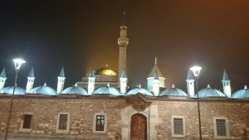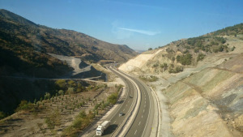

Rum-Tomb –Konya by night, Turkish Landscape-Eskisehir-

Mevlana Walks-Konya..A lesson on Mentorship

http://wp.me/piL5Q-H3

A carpet weaver asked me if I had visited the Tomb of Shams.
"No one knows where Shams is, how he disappeared. Even Rumi could not find him in his lifetime, and many of his spiritual poems speak of this loss and love. So how can there be a tomb of Shams?" I asked a local person from Konya.
He agreed that no one knows where Shams is.
But then, Shams is everywhere.
This story teaches us about the informal but vital role of Mentors in all aspects of life. Remembered and did a thanksgiving prayer for some of my mentors at the tomb of Shams of Tibriz in Mevlana, Konya

Sukh Sagar-San Gjwann-Malta-2012-March Xlendi-Gozo-2010-December

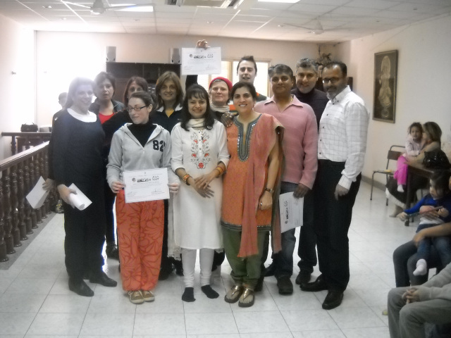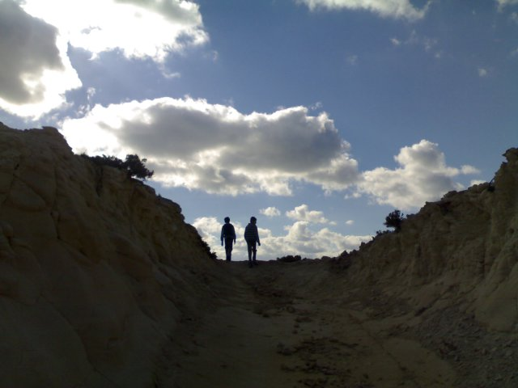

Toronto Zoo-2015-July Ontario Science Centre-2015-July

